SIR C.R. REDDY COLLEGE OF ENGINEERING

(Affiliated to Jawaharlal Nehru Technological University, Kakinada)

ELURU, W.G.Dist., (A.P)

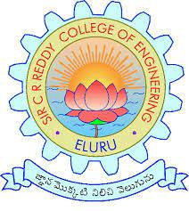

This is to certify that this is a Bonafede record of the project work entitled " THE IMPACT OF SMART PHONES AND MOBILE DEVICES ON HUMAN HEALTH AND LIFE done by **Pemmani Anjaneyulu** bearing Regd no **20B81A05D3** a student III-B.Tech., 5th semester in the Department of Computer Science and Engineering of Sir C.R. Reddy College Of Engineering, Eluru, during academic year 2022-2023

Signature of Lecturer Signature of the

Head Of the Department